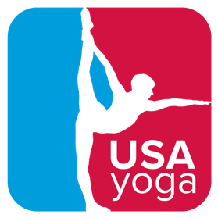
USA Yoga 2024 Season
Sponsorship Rates

Season Sponsor $2,500 (Reserved)
- Your logo on USA Yoga constituent communications
- Your logo prominently displayed on USA Yoga website with sponsor landing page
- Your logo listed on USA Yoga events throughout the season
- Featured logo and :60 video commercial on USA Yoga championship slide decks for nationals and qualifiers
- Your logo on the USA Yoga 2024 championship t-shirt
- USA Yoga 2024 Championship Season t-shirt (up to 3 shirts)

Nationals Sponsorships $500 - $1,000
- Mention each time your sponsored division is mentioned
- In-person recognition and opportunity to speak if your representative is present
- Reserved seats at championship if your representative is present
- Logo on USA championship slide deck for nationals and qualifiers
- Vendor space at the event to sell your products or services and interact with athletes
- USA Yoga t-shirt and event goody bag
- Opportunity to include coupons or product in goody bags

Women’s 18-49 Sponsor $1,000
Men’s 18-49 Sponsor $750
Women’s 50+ Sponsor $750
Men’s 50+ Sponsor $500
Youth Division Sponsor $500
Studio or Business Sponsor $200 (excludes vendor space and t-shirt)

Business or Studio Package $700
Sponsor all three live qualifiers: Chicago, NJ, and San Jose and two live virtual qualifiers ($100 each) and get a nationals business sponsorship ($200)
- Reserved seats at championship if your representative is present
- Logo on USA championship slide deck for nationals and qualifiers
- Vendor space at the event to sell your products or services and interact with athletes
- USA Yoga t-shirt and event goody bag
- Opportunity to include coupons or product in goody bags

Single Live Qualifier Sponsor $200
- Logo on USA championship slide deck for qualifier
- Vendor space at the event to sell your products or services and interact with athletes
- Event goody bag
- Opportunity to include coupons or product in goody bags

Single Qualifier Business or Studio Sponsorship $100
- Logo on USA championship slide deck for qualifier

